**The Room 2.0**

*Adapted from the Guardian by Guilpain Léo*

You are a student and you do not have enough space in your room? In that case, you came at the right moment. In the following, you will discover the room I have decided to present you in order to make you a better life.

As you know, living in 20 square meters, it is sometimes complicated. Thus, a lot of people have tried to ensure that the room is removable. That is to say that some furniture is flexible and allow to let the place for other furniture. This technical is quite smart.

On the other hand, I do not think that it is the good solution. You, like me, after a day of classes, we are not ready to move the bed in order to work every day. That is why, according to me the room of the future must be standard without moving furniture but it must be composed with furniture which makes it better.

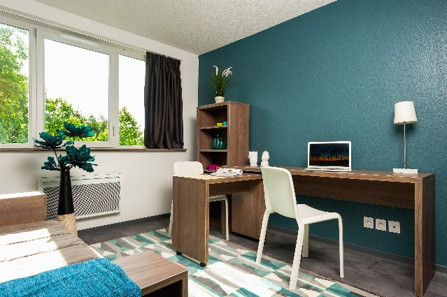

It is the case of the invention created by Vincent to control the temperature (increase and reduce) with a tablet computer but also of the solar plug invented by Hugues. These little gadgets allow them to make the room environmentally friendly but also automated without requiring efforts to students.

If with this article, you do not want to live in this room, I do not know what to do anymore. Act like me, insist on college administration in order to convince him accepting the project of that room 2.0.